Abhinav Dinesh Srivatsa

21BDS0340

Information Security Management

Assignment – I

**Question 1**

**Aim**

To connect two networks using a router

**Procedure**

1. Select 1 router, 2 switches and 6 PCs
2. Connect the 2 switches to the router on the gigabit ethernet ports
3. Connect 3 PCs to the first switch and 3 PCs to the second switch
4. Assign 192.168.10.1 to the gigabit ethernet 0/0 on the router and 192.168.20.1 to the gigabit ethernet 0/1
5. Assign the first 3 PCs IP addresses 192.168.10.2 to 192.168.10.4 and the second 3 PCs IP addresses 192.168.20.2 to 192.168.20.4
6. Pinging each computer from one another should now work

**Screenshots**

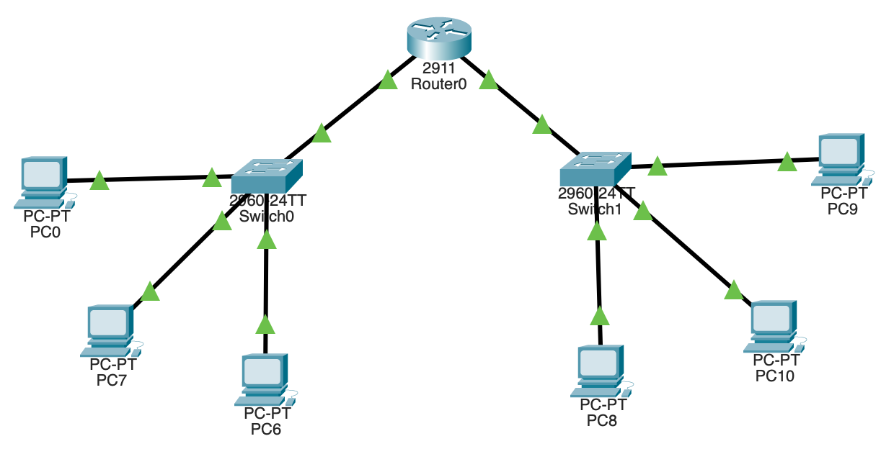

**Result**

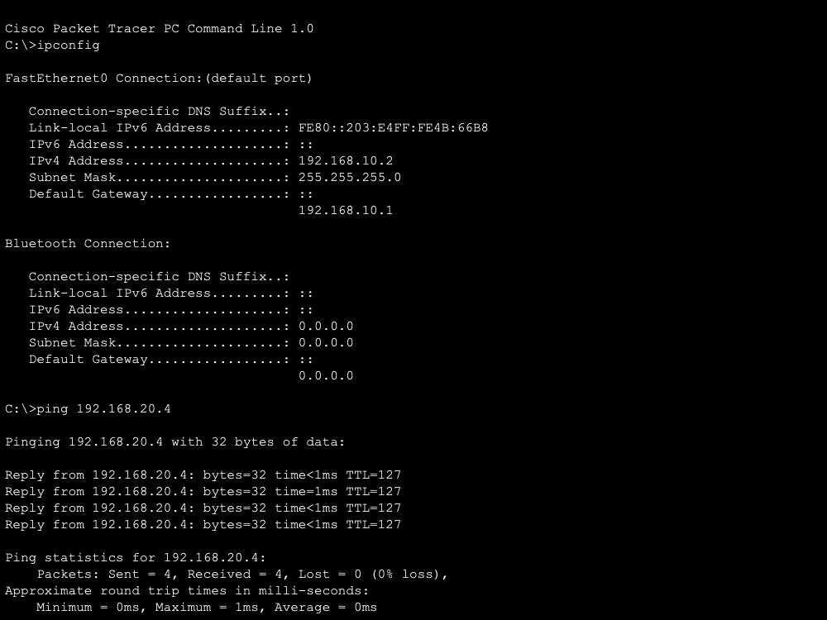

**Conclusion**

This packet tracer demo has been constructed to successfully demonstrate connection two different networks with a router as an intermediate.

**Question 2**

**Aim**

To configure an access control list (ACL)

**Procedure**

1. Select 1 router, 1 switch, 1 server and 2 PCs
2. Connect the switch to the router on the gigabit ethernet port
3. Connect the server to the router
4. Connect the 2 PCs to the switch
5. Assign gigabit ethernet 0/0 as 192.168.10.1 for the PCs
6. Assign gigabit ethernet 0/1 as 10.10.10.1 for the server
7. Set the server IP address as 10.10.10.11
8. Set the PCs IP addresses as 192.168.10.2 and 192.168.10.3
9. Configure the ACL through the router terminal
10. PC 192.168.10.2 should not be able to access the server, while 192.168.10.3 can

**Screenshots**

**Result**

**Conclusion**

This packet tracer demo has been constructed to successfully demonstrate denial and access of services through an access control list set configured on the router.

**Question 3**

**Aim**

To configure DHCP and firewall on a server

**Procedure**

1. Select 1 server, 1 switch and 3 PCs
2. Connect all the PCs and server to the switch
3. Enable the DHCP option and configure the IP as 1.0.0.1
4. In all the PCs, enable the DHCP protocol to assign IP addresses

The following steps are for the firewall setup:

1. Go to the firewall settings in the server
2. Add a deny rule for all ICMP traffic on all IPs with a complete mask
3. Add an allow rule for all IP traffic on all IPs with a complete mask
4. The webpage should now be accessible, but pinging will be prevented from the PCs

**Screenshots**

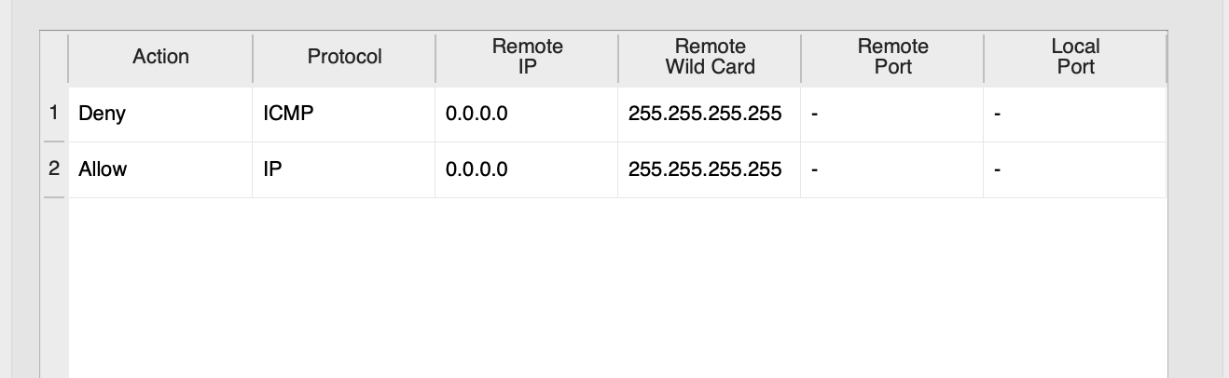

**Result**

**Conclusion**

This packet tracer demo has been constructed to successfully demonstrate dynamically configured IP addresses and also denial of ICMP and allowance of IP through the server firewall.